- On this page can we change the text to –

We at APM Capital are a team of highly skilled, technically superior, and extensively experienced individuals who aim to provide a thorough trading experience based on transparency, fairness, and the next generation of technologically advanced trading solutions.

- Mission statement –
Our mission at APM Capital Limited is to provide clients from all financial backgrounds and levels of experiences access to global markets with excellent customer service, enthusiasm, and energy.

APM Capital Limited offers a unique trading experience to people from all financial backgrounds and levels of experiences, by providing them access to global financial markets.

- Can we add the following risk disclosure at the bottom of the page –
Risk warning: OTC derivatives are leveraged products and if you are a professional client, you could lose substantially more than your initial investment. Trading OTC derivatives may not be suitable for everyone so please ensure that you fully understand the risks involved and take care to manage your exposure. APM Capital Limited does not issue advice, recommendations, or opinion in relation to acquiring, holding, or disposing of OTC derivatives nor is APM Capital a financial advisor. All services are provided on an execution only basis. APM Capital Limited only provides information of a general nature and does not consider your financial objectives, personal circumstances. We recommend that you seek independent personal financial or legal advice.

APM Capital Limited is registered at at 3508, 35, Al Maqam Tower, Abu Dhabi Global Market Square, Al Maryah Island, Abu Dhabi, United Arab Emiratesand is regulated by the FSRA under FSP number 200034.

The information on this site is not intended for use by any person in any country or jurisdiction where such distribution or use would be contrary to local law or regulation.

- Can we remove our team tab from company?
- From the platforms can you remove cTrader and CQG and only keep Ark and MT5? We will add these two later. Also, please remove the write up that shows up when you click on/hover over platforms.
- Can we add download links for MT5?
  - Windows –
  - Mac -
  - Web trader –
- Can we add download links for Ark?
  - Windows –
  - Mac -
  - Web trader –
- Can we take treasuries out as an option from markets?
- For the economic calendar can we add an RSS feed from https://www.forexfactory.com/calendar
Leave for moment
- Can we take this out from the contact us section?

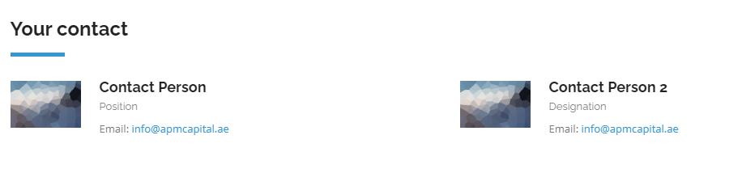
- We might need to set up different pages for retail and professional clients. Maybe something like this (without the group option)
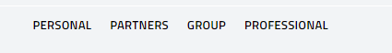

--------------------------------
Updated Notes

Amro

-remove have any questions- From the header
This hasn’t been done
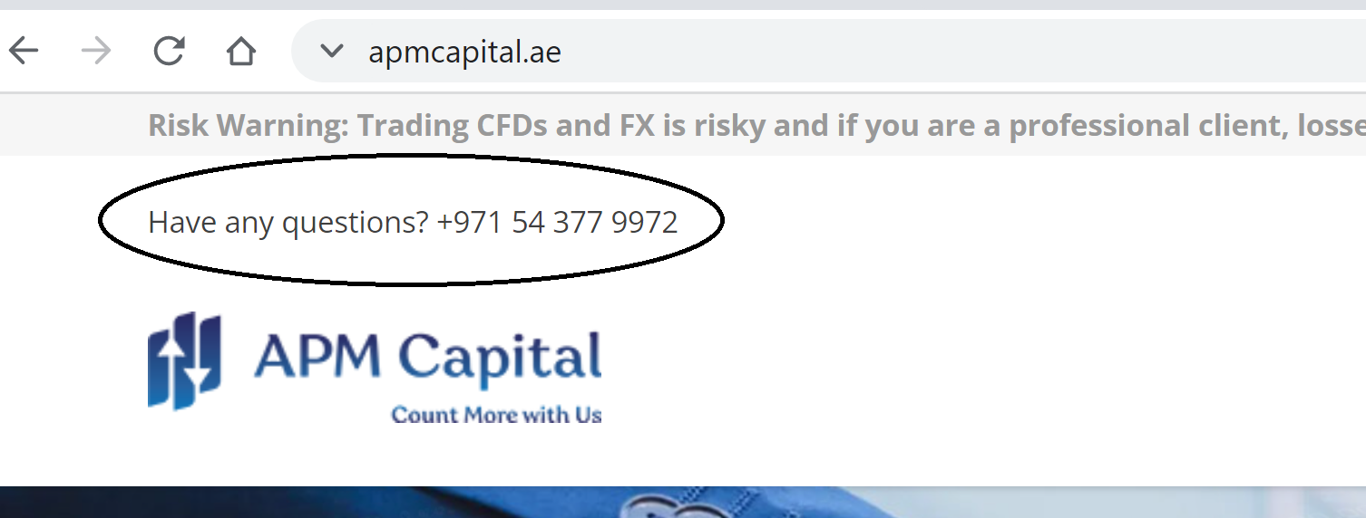
-replace the risk warning with this warning in header and make it sticky to top of browser: CFDs are a leveraged product and can result in losses that exceed deposits. CFDs may not be suitable for everyone so please ensure you fully understand how CFDs work and what their risks are, and take care to manage your exposure
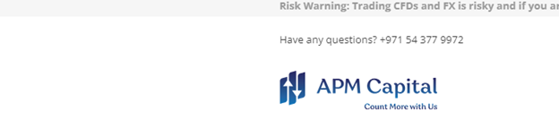
This hasn’t been done
- Connect our linkedin page : https://www.linkedin.com/company/apm-capital-limited?trk=ppro_cprof

- Remove the current time period
- Can we take out the below and add this ticker instead: Here is our ticker link https://apmweb.arktechltd.com:252/ticker/currencies Can we add as an iframe?

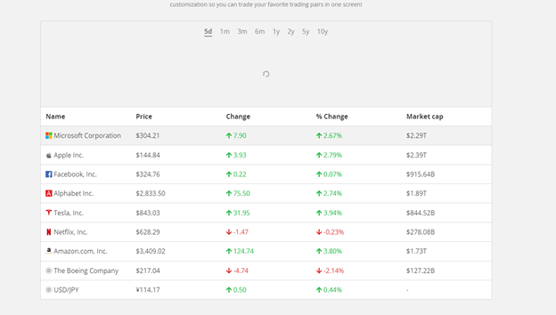

- Remove this image from ARK page
- Remove image next to it aswell and Amro to send new image.
- 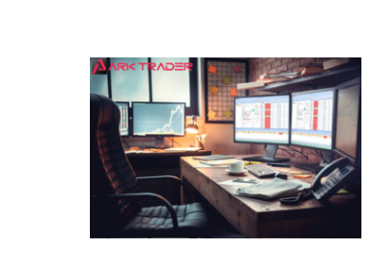

-remove
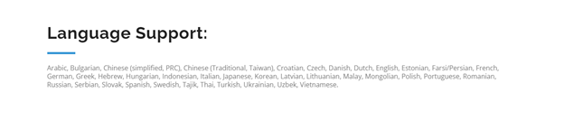

- Remove link to download the app for webtrader and replace it with click to launch APM Capital’s ARK webtrader
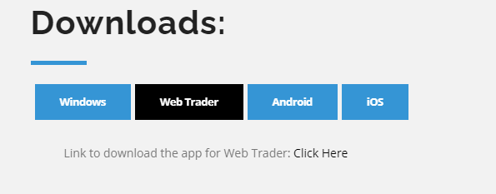

- Remove why choose mt5 from ARK page
- 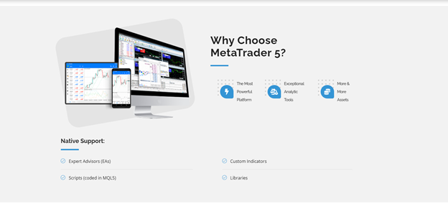

- Remove who uses metrader and advanced features and functionalities
- Remove from ark and MT5 page
- 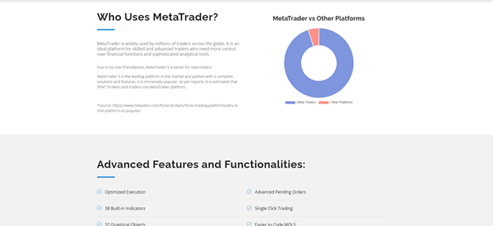

- Remove tutorials and FAQs from ARK and MT5 pages
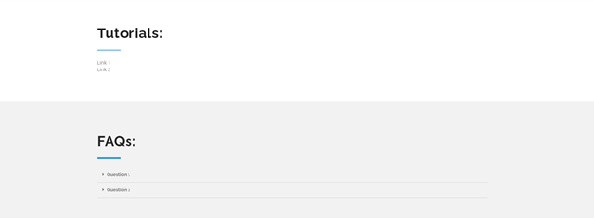

- Remove all the pictures from mt5 page except for the pictures with the numbers below
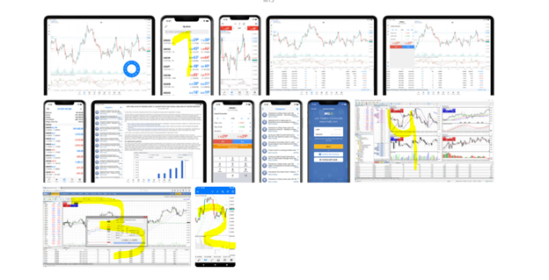

- Remove why choose mt5 from mt5 page
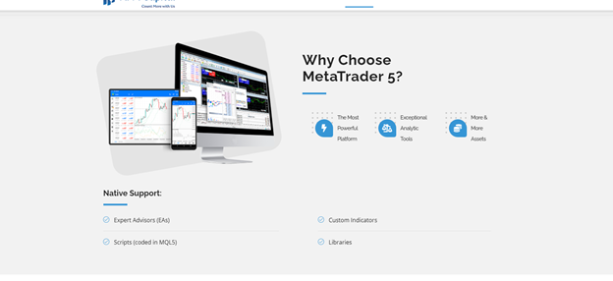

- Remove who uses mt and advanced features and functionalities
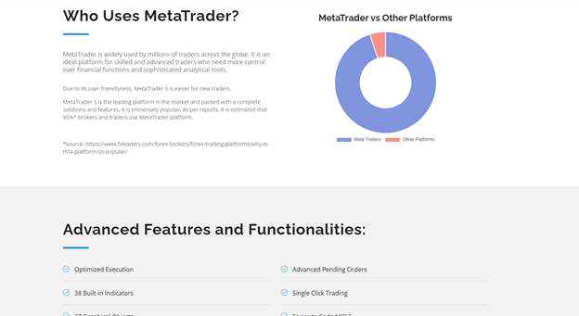

- Remove language support from mt5 page
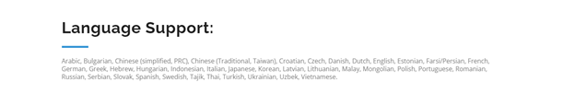

- Remove the below from the platforms page
- And on the individual ark and mt5 pages
- This isn’t done on the Meta trader and ark pages
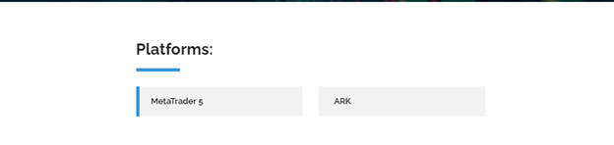

Fiachra
HOME PAGE OR FRONT PAGE
https://www.apmcapital.ae/

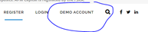
Dead link – can we get linked to demo section or demo registration


24/5 I think would be better
You need to change it to say x5 not x7
In footer change from Monday to Friday
And remove telephone number

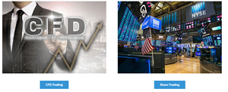
Can we link these images of CFD and NYSE to the same place as the boxes underneath them
You have not done this
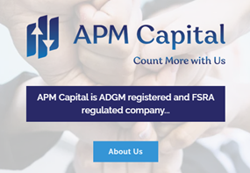

APM Capital is ADGM registered and FSRA regulated company…
APM Capital is registered with ADGM and is a FRSA regulated company
The above isn’t done on the banner
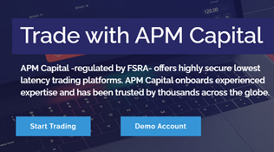

APM Capital – regulated by FSRA – offers highly secure lowest latency trading platforms. APM Capital onboards experienced expertise and has been trusted by thousands across the globe.
APM Capital offers secure, low latency trading platforms that offer clients the best experience when trading
The above is not done either. You have mixed up THE TWO SEPARATE banners.


Trade in the Suitable Way to You!
APM Capital provides you with the flexibility to choose from two distinct trading ways.
Trade Your Way!
APM Capital provides you with the flexibility to choose from two distinct trading ways

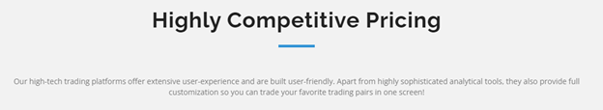
Highly Competitive Pricing
Our high-tech trading platforms offer extensive user-experience and are built user-friendly. Apart from highly sophisticated analytical tools, they also provide full customization so you can trade your favorite trading pairs in one screen!
Our high-tech trading platforms are built to suit the user. They offer highly sophisticated analytical tools and provide full customization so you can trade you favorite trading pairs in one screen.


Trade on the Go!
Trade on the go!
Get the complete access of your trading account whenever you need, wherever you are! Download the app now!
Get complete access of your trading account whenever you need, wherever you are
Take out the explanation mark you added and just change to a full stop
<New line>Download the app now <New line>
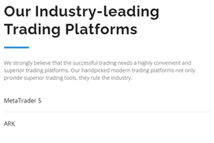

Our Industry-leading Trading Platforms
Our industry-leading trading platforms
You haven’t done the above
We strongly believe that the successful trading needs a highly convenient and superior trading platforms. Our handpicked modern trading platforms not only provide superior trading tools, they rule the industry.
We believe that successful trading needs highly convenient and superior trading platforms. Our handpicked modern trading platforms provide clients with in-depth technical analysis tools and state-of-the-art trading capabilities

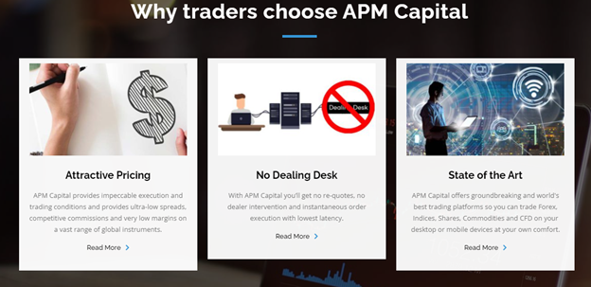
Attractive Pricing
APM Capital provides impeccable execution and trading conditions and provides ultra-low spreads, competitive commissions and very low margins on a vast range of global instruments.
APM Capital provides ultra-low spreads, competitive commissions, and very low margins on a vast range of global instruments.
No Dealing Desk
With APM Capital you’ll get no re-quotes, no dealer intervention and instantaneous order execution with lowest latency.
With APM Capital you’ll get no re-quotes, no dealer intervention and instantaneous order execution.
State of the Art
Next generation platforms
APM Capital offers groundbreaking and world's best trading platforms so you can trade Forex, Indices, Shares, Commodities and CFD on your desktop or mobile devices at your own comfort.
APM Capital offers the world's best trading platforms so you can trade Forex, Indices, Shares, Commodities and CFDs on your desktop or mobile devices at your own comfort.

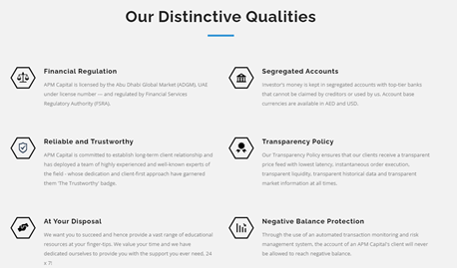
Our Distinctive Qualities
Financial Regulation
APM Capital is licensed by the Abu Dhabi Global Market (ADGM), UAE under license number --- and regulated by Financial Services Regulatory Authority (FSRA). <Can we add our license number> Their license number is in the footer, please add where the 2 dashes are i.e:
APM Capital is licensed by the Abu Dhabi Global Market (ADGM), UAE under license number 200034 and regulated by Financial Services Regulatory Authority (FSRA).
Reliable and Trustworthy
APM Capital is committed to establish long-term client relationship and has deployed a team of highly experienced and well-known experts of the field - whose dedication and client-first approach have garnered them 'The Trustworthy' badge.
APM Capital is committed to establishing long-term client relationship and has built a team of highly experienced experts. Our team’s foundation is built on a client-first approach.
At Your Disposal
We want you to succeed and hence provide a vast range of educational resources at your finger-tips. We value your time and we have dedicated ourselves to provide you with the support you ever need, 24 x 7!
We want you to succeed. We provide a vast range of educational resources at your fingertips. We value your time, we have dedicated ourselves to provide you with all the support you ever need, 24/5.
Segregated Accounts

Investor’s money is kept in segregated accounts with top-tier banks that cannot be claimed by creditors or used by us. Account base currencies are available in AED and USD.
All client funds are kept in segregated bank accounts with top-tier banks with restricted access. Account base currencies are available in AED and USD.
Transparency Policy

Our Transparency Policy ensures that our clients receive a transparent price feed with lowest latency, instantaneous order execution, transparent liquidity, transparent historical data and transparent market information at all times.
We need to look at this
Negative Balance Protection
Through the use of an automated transaction monitoring and risk management system, the account of an APM Capital's client will never be allowed to reach negative balance.
Using automated transaction monitoring and risk management systems, client accounts will never be allowed to reach negative balance.

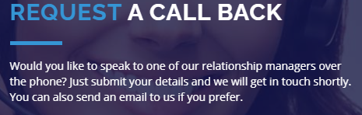
REQUEST A CALL BACK
Would you like to speak to one of our relationship managers over the phone? Just submit your details and we will get in touch shortly. You can also send an email to us if you prefer.

Request a call back
We are always here to help. If you would like to speak to one of our relationship managers over the phone, simply fill in your details in the form below, and we will get in touch with you shortly.


Can we link up our social media to these links – if we don’t have links can we get the buttons removed
Just linked in
You haven’t done this you need to remove facebook and twitter icons.
In header for Trading add share trading coming soon.
Markets – no link
Trading – Linked
Platforms - Linked
Company - Linked
Education - no link
Contact - Linked
Either they all get linked or none of them do – should be consistent
Trading
https://www.apmcapital.ae/trading/
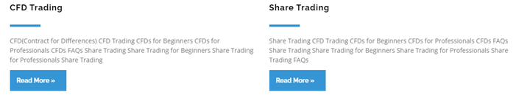
CFD(Contract for DIfferences) CFD Trading CFDs for Beginners CFDs for Professionals CFDs FAQs Share Trading Share Trading for Beginners Share Trading for Professionals Share Trading
A CFD is a Contract for differences. This type of financial instrument allows you to trade an underlying index, share or commodity contract without having to own it. Contact us to find out more about CFD Trading
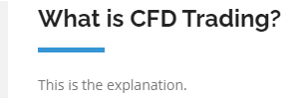

Trading contracts for difference (CFDs) is a way of speculating on financial markets that doesn’t require the buying and selling of any underlying assets. Instead, when you trade a CFD, you are agreeing to exchange the difference in the price of an asset from the point at which the contract is opened to when it is closed. One of the main benefits of CFD trading is that you can speculate on price movements in either direction, with the profit or loss you make dependent on the extent to which your forecast is correct.

COMPANY
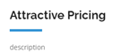
APM Capital provides ultra-low spreads, competitive commissions, and very low margins on a vast range of global instruments

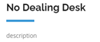
With APM Capital you’ll get no re-quotes, no dealer intervention and instantaneous order execution

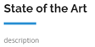
State of the Art
Next generation platforms
APM Capital offers the world's best trading platforms so you can trade Forex, Indices, Shares, Commodities and CFDs on your desktop or mobile devices at your own comfort.
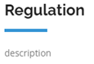

APM Capital is registered with ADGM and is a FRSA regulated company

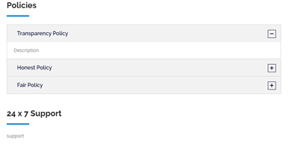
<I would remove this section >
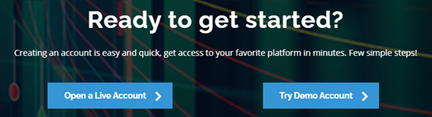

Creating an account is easy and quick, get access to your favorite platform in minutes. Few simple steps!
We need these links to go to the account opening sections

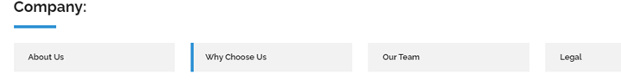
Remove “Our Team” from here

Extra Notes
- Add vision statement
- Replace the ticker with FX instead of equities -Amro to send
- When we click on the ticker maybe it should link to the website, we get the RSS feed from (later)
- Take out the read more from the instruments section and add a small description
- Remove highly competitive pricing bit
- Make sure the risk banner appears at all times
- This has not been done – The risk banner above the header they wanst to be sticky o it always shows when you scroll down.
- Add email and remove drop down list for request a call back -Home page above footer

Make the website responsive

