PROJECT NAME | Making Ohio
PROJECT IN CHARGE | Rajeev Sharma
MODULE | Test Missing Data on Whole Website
DATE | 13-May-2022
QA Date | 16-May-2022

*** Careers Page ***
(https://makingohio.com/careers/)

1.Slider Below the section Industrial Maintenance of Career Page are showing broken images
QA Comment – Not Fixed
- Auto Design Engineer
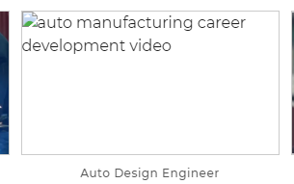
- Material Handler
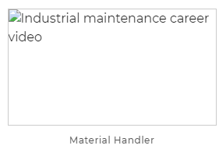
2.Three Cards above the Get involved Red Bar with Footer showing broken image (Career Pathways)
QA Comment – Done
- 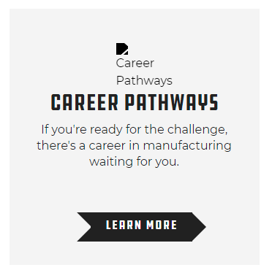

3.Manufacturing Video Page – Sub Category of the Career Page banner image is Missing (https://makingohio.com/careers/manufacturing-videos/)
QA Comment – Done

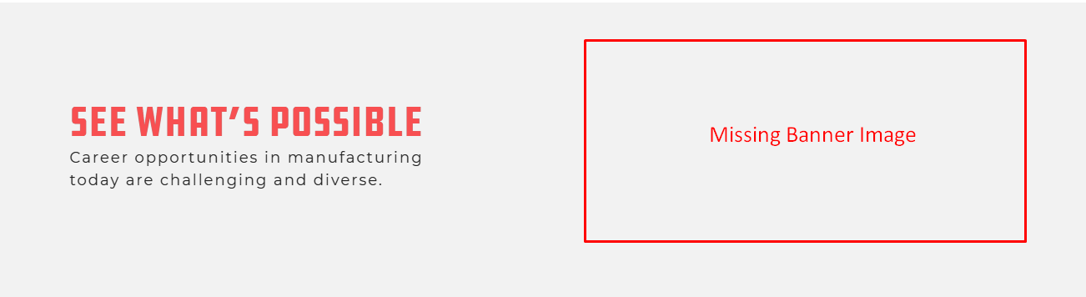

4.Career Pathways Page - Sub Category of the Career Page – 4 cards under the section Which Path Will You choose Broken Images are showing
(https://makingohio.com/careers/career-pathways/)
QA Comment – Done

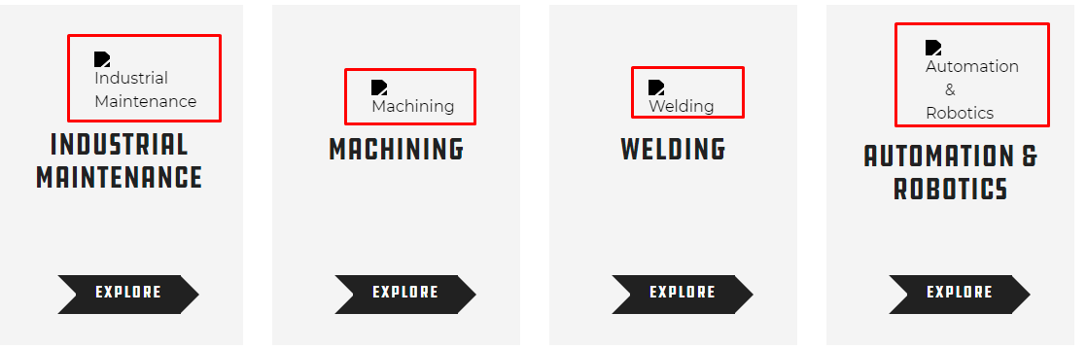

*** Resources Page ***
(https://makingohio.com/resources/)
1.Broken Images are showing in the boxes under the section Educator Resources 6 images are broken
QA Comment – Not Fixed (A R EXPERIENCE image is broken)
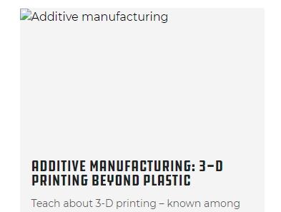
*** Contact Us Page***
(https://makingohio.com/contact/)
1.The Ohio Manufacturer’s Association Logo is broken
QA Comment – Done
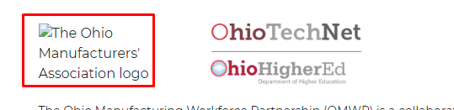

*** Home Page***
(https://makingohio.com/)
1.Slider below the Find Success video 1 image is broken
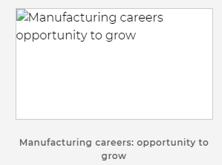

*** Career Pathways Page***
(https://makingohio.com/careers/career-pathways/industrial-maintenance-pathway/)
1.Three cards below Explore Other Pathways are showing broken images
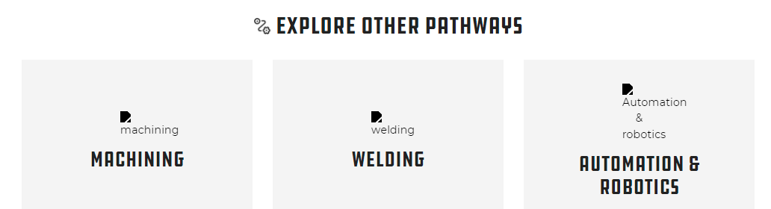

2.Similarly For Machining Page icons are showing as broken
https://makingohio.com/careers/career-pathways/machining-pathway/
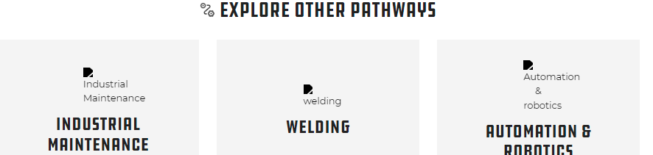

3.Missing Data on Welding Pathways Page
(https://makingohio.com/careers/career-pathways/welding-pathway/)


