
ve.google.com/file/d/10oU_G6SFpORZY2_YRdUHKNkfvFddOxVw/view?usp=sharing
Scope of Work Document
for
Website for app content marketting
Document Version: V 1.0
Prepared By: Visions
Prepared On 8th April 2022



Thank you for sharing the detailed information.
Please see the list of tasks to be done
Task 1: We will setup the clone of the website to implement the changes as per scope requirement.
We don’t need to clone the website. We can work directly on the live site as it’s not live to the public yet.

Comments 12.04.2022: Ok.
a) Sign up Form.
https://app.inventorygraphics.com/register
Task 2: When a new user is setup through the register page, confirmation email needs to be sent to hello@inventorygraphics.com.
Yes. We just need to be sure all the fields are sent in the email including password and FTP credential information.
We assume the email format (Template) remain the same.
Comments 12.04.2022: Ok.
Task 3: We need to create an FTP User for the dealer that will be unique and will have only access to upload CSV file. This will be created automatically on user registration.
Below details will be send to hello@inventorygraphics.com
- FTP HOST
- FTP Username
- FTP password
- FTP Port.
Note: The information received on email will be sent via email to customer by admin manually as per our discussion on Upwork. Please let us know if that is ok.
Yes. Nothing should be sent to the customer.
Comments 12.04.2022: Ok.
Question: Disk Management – Software/We will not be responsible for managing the space on AWS server. It will be handled by you manually. Please confirm.
There will not be any limit of data that a user can upload on the allocated folder. In case the space is not available do we need to let user register and FTP will be provided later by admin manually. Please confirm?
Yes. But can we make it so that old CSVs are deleted after 30 days? And images that we update and save with new backgrounds on our server need to be deleted on our server after 30 days as well.
Comments 12.04.2022: Ok, we will create schedular that will remove files older than 30 day ( CSV Files only ) .
Questions: Images are linked with inventory and Lot locations. In case those are deleted the inventory list will show list with records whose images are not found. So it will be separate task we recommend to be done on Phase2 later.

B) Setting / Profile page on client dashboard.
Task 4: User will be able to add the below information which will be used to post the updated CSV
- FTP HOST
- FTP Username
- FTP password
- FTP Port.
Task 5:
We currently have New and Used settings separated. However, we’ll need another section for “Lot Location”. This is for dealers who have 2 different physical locations for New Vehicles and want different background images and settings.
Comments: We need clarification on this. Please see our assumption and question(s) below:
- Lot Locations:
As per our understanding user will be able to add Location first.
Locations:
- Add Location (Location Name, Location Address)
- Listing of Address (Update and Remove)
Please see attachment “LotLocation.png” – it shows there’s a column in the CSV where the customer will input which Location it is
Comments 12.04.2022: ok will that just be name ?.
It will just be blank or Lot2. Lot2 needs a different photo thank Lot1 (which is listed as blank).
- Setting page - Based on locations client can add background images for New and unused vehicles.
Client will be able to choose from the dropdown as per screenshot below:
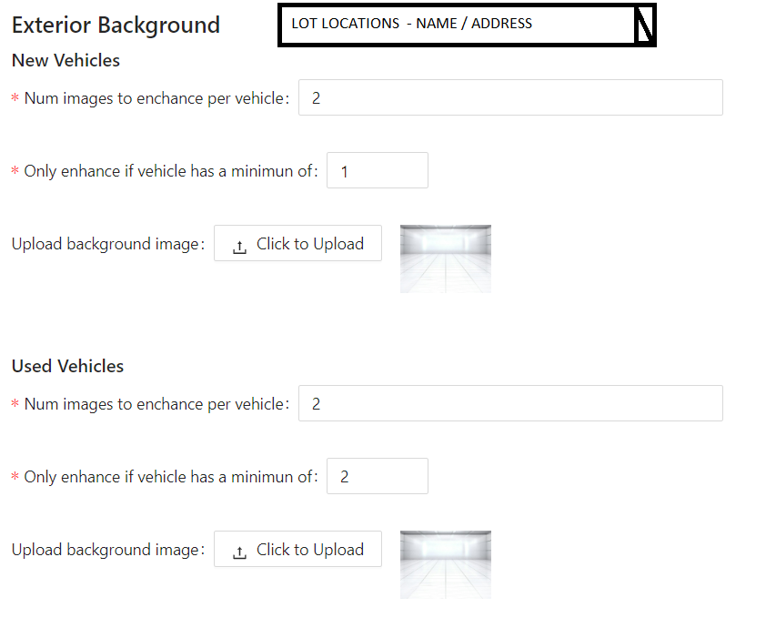

QUESTION FOR LOT LOCATION FUNCTIONALITY:
i) Will there be any changes needed on the inventory list?
This is fine.
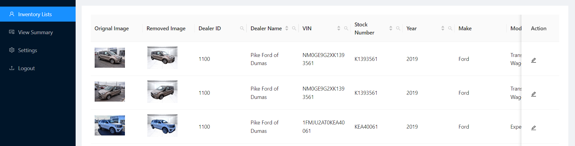

ii) Will the CSV have locations associated with each vehicle?
Yes. Most customers will not have a Lot Location usually. But there are some customers who do have it like the example I showed. So they have 3 different backgrounds. New Lot Location 1, New Lot Location2, and Used Background. But again, 90% of customers will usually have 1 background for all vehicles, new or used.
Comments 12.04.2022: Ok.
iii) Remove Location- Do we need this option? In case yes then do we need to remove the inventory vehicles added on that location?
What do you mean by remove location? Is this still referring to Lot Location?
Comments 12.04.2022: Yes, Do we need to provide option to remove LOT ?
No, client will specific if they have a Lot2 or not. We don’t adjust anything with this other than put a different background. Let me know if that makes sense.

Task 6: Client Management – ADMIN
Admin will be able to delete users.
Admin will be able to filter and sort.
Admin will be able to view all the information added by user in setting page.
- Dealer Information
- Exterior Background (New and Used Vehicles)
- Locations
- Note/Comments
- FTP Details of our server (for them to put daily CSV into our server)
- FTP Details of client’s sever (for us to put new CSV into)
Comments 12.04.2022: Ok.

Task 7:
a. Be able to receive client CSV files through FTP with this file naming structure (YYYMMDD_DID.csv). (DID = Dealer ID)
b. Keep old CSV files for record (for 30 days as mentioned above)
Comments 12.04.2022: ok.
c. Make sure VINs that were previously edited aren’t done again (this is already complete) - but IF the client retakes new photos for any VIN then make that new photo appear in the admin so I know I have to redo the cut out for that VIN.

Comments:
We will create scheduler that will pick up the CSV uploaded by dealer and upload the information on database. Only those records will be shown whose VIN is new and it doesn’t exist on our database.
Admin will then update the images accordingly. Actually, let’s just show the updated image even if we already did that VIN so that we can re-do it. But in the “View Summary” tab of the client view, can we show how many re-do images were done and add that to the sum?
Also, can you make this “View Summary” page available on the Admin page so that I can view each client individually easily?
Comments 12.04.2022: Can we do this on phase 2 later as the estimates may change accordingly. Since this is an existing functionality change request.
OK yes of course.

We need to provide functionality to sort records based on the CSV files shared by Dealer.
We need to add PUSH Now button to send CSV to Dealer FTP Account.
The CSV will be moved to Archive folder. (Our archive folder and to client’s FTP folder).
Comments 12.04.2022: Yes
Questions:
- Will the format of CSV will be same for each dealer? Please confirm.
Great question. Most of them will, but some customers will have slightly different formats.
Comments 12.04.2022: We need some fix format to identify the information to be uploaded on database.
OK
We can do the following
- Provide dealers sample files so they can share the files on same format.
- Or if the labels are fixed then we can use those accordingly.
Please share your thoughts.
- Will they provide/Upload the CSV on FTP location
in a specific time? Please confirm?
Yes, they are usually entered by 9pm PST.
Comments 12.04.2022: Ok.
- Do we need to make any other changes on CSV except updating the images provided?
Only image file URL separated by pipe (|) – nothing else.
Comments 12.04.2022: Ok.
- We assume the CSV information will be displayed on Inventory listing that already exists. Please confirm.
Yes, it’s only live and active inventory from their website. For instance, if an old cars is on the CSV for the past 10 years every day, it means it’s not sold yet. Whatever is on the daily uploaded list is active inventory.
Comments 12.04.2022: Ok.
- Do we need to send all the records that we received on CSV?
For example, if the CSV contains records which are already available on our database do we need to resend them?
The CSV should send back the entire thing the way it was sent to us with the same exact VINs. The ONLY thing(s) that would change are the new URL(s) of images. Some dealers choose to only do the 1st image and some want the 1st and 2nd images so it will depend on the customer how many image URLs per car we will update and send back.
But if only 2 new VINs were added today (for example), we would only update the 2 new ones and leave the others alone.
Comments 12.04.2022: Ok.
Please see the flow diagram.
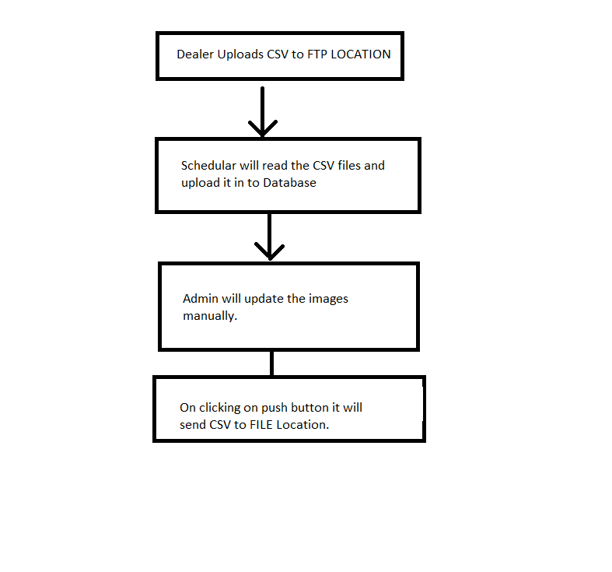
Yes. Wonderfully done. Thank you!

