
https://drive.google.com/file/d/10oU_G6SFpORZY2_YRdUHKNkfvFddOxVw/view?usp=sharing
Scope of Work Document
for
Supplier Module
Document Version: V 1.0
Prepared By: Visions
Prepared On : 11th Jan 2022

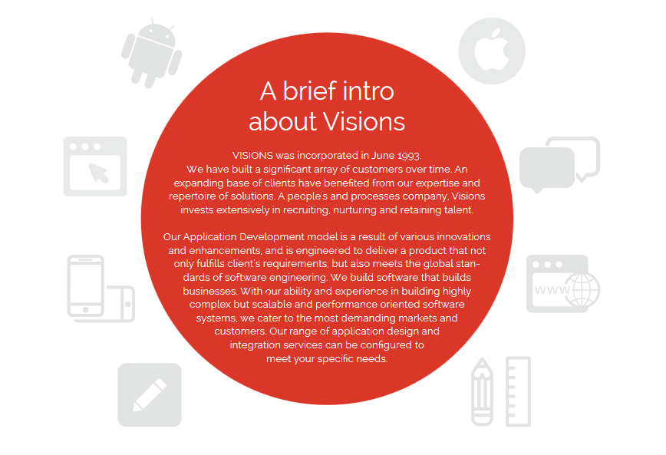

Project Overview

As per our understanding we need to create the supplier module from where user of the portal 360 will be able to create the purchase request and send it to the user who has authority for the “approval of the request”. The authorized person can select the purchase request to generate the purchase order. System will allow user to enter the suppliers into the system.
The user who has authority to generate the purchase order can select the order to generate the invoice. User can also inspect the item and system will maintain the logs of the status added for the item.

1. Product Perspective

- Develop and design the module containing features- Purchase requisition, Order, and supplier module.
- Purchase requisition module
- Purchase order module
- Supplier module
- Inspection of the items and maintaining logs into the system.

2. Constraints

- Super admin portal – In English
- User login portal – In English

3. Functional Requirement

Followings are the features of the module we need to design and develop –

3.1 Modules –

- Purchase Requisition Modules- User will be able to create the purchase request by clicking on the module. Once the user clicks on the module followings are the screen visible.

- Purchase request Listing- By clicking on the purchase request module screen will show the purchase requests made till the date. Following are the details shown on the list.
  - Supplier name
  - Date of request
  - Date of delivery
  - Action (Edit/active)
  - Create Request
- Create purchase request- By clicking on the “Create request” following screen will be opened containing following fields.
  - Sr No- Autogenerated
  - Date of request – By default todays date
  - From- Diagnostic 360 address
  - To- Supplier’s name from dropdown
  - Item details -Text field
  - Preferred make – Text field
  - Quantity required- Text field
  - Required delivery date- Text field
  - Add more icon- to add more products
  - Indented by- Name of the user who has created the indent (request)
  - Select Approval- Dropdown
  - Send button
- Once the request is created and send it to the “Approver” user who has authority to approve the request, will receive the notification on their mail. After receiving notification user will login into the system and check the request. He/she will send the request .
- Need to save the purchase request with the “executor” stamp detail (name, date, and time) once the approver approves the request.
- Request for the purchase will be sent to the supplier and after this the quotation will be communicated on the mail.
- Once the user has sent the purchase request and quotations have been received. Next step is to create purchase order once the quotations are received, and supplier is finalized.
- Purchase Order- Once the quotations are received, purchase order needs to be created into the system. The user who has authority to create the purchase order.

- Click on the purchase request whose order needs to be created.
- PO Number- Do we need to follow any prefix for the number.
- Invoice address
- Delivery date
- To- Select the supplier name
- After selecting the supplier name address and contact number will be automatic populated on the system
- Delivery address- company’s address automatic populated
- Rest details related to quote amount will be calculated automatic
- Tax will be calculated at 15 %
- Additional comment- Text
- Approved by-User name
- Send button at the place of the signature

3. Purchase Order Listing- Listing will contain the purchase orders made till the date with rating of the supplier. Followings are the details needs to be shown on the screen.

- Supplier name
- Purchase order no
- Date of request
- Invoice status
- Ratings
- Action column
3.1 Invoice Paid- Once the purchase order is generated for the supplier, and the item is received in the company. The inspection procedure has started after arrival of goods.

- Inspect Items- We assume items received in the company will be inspected first and if the item is inspected good then items will be marked as condition -good and invoice paid check box will be selected. So that invoice paid record can be generated.
- We will provide the option on the purchase order to mark the condition good or bad.
- Option for invoice paid will be given on the purchase order screen once the condition of the item is good.
- We assume user can mark the items “bad” in condition and those items will be returned back to supplier. If some of the items are in good condition and some are in bad, then purchase order can be edited for the items in good and invoice paid after removing the items in bad.
  - Case-1 -In the inspection the items are marked all good. Then invoice can be paid, and supplier can be rated from the PO screen.
  - Case-2 -In the inspection, some of the items found in bad condition and some are in good condition. The items in bad conditions are decided to send back to the supplier and after this the purchase order can be left as it is.
  - Case-3 -In the inspection, some items are in good condition, and some are in bad condition. User can decide to return the bad items back and does not want to receive them again. Then user can mark the PO as invoice paid after Editing the purchase order item details.
- Note- We assume we don’t need to follow any of this case. Items will be marked either good or bad and then invoice will be paid, none of the case of return the item needs to be managed in the system.
3.2 Supplier rating - User will be able to rate the supplier after invoice paid of the order. User can click on the “rate supplier” on the purchase order screen. User can rate the supplier out of 4 criteria (Delivery time, condition of item, Ease of communication, delivery matching). Rating will be shown at the purchase order screen and also the average rating of the supplier will be on supplier listing(detail view of supplier).
4. Supplier – User can add the suppliers in to the system by clicking on the “Supplier” screen. Followings are the details needs to be filled while adding the supplier into the system.

- Supplier Listing- This screen will show the number of supplier present into the system till the date.
  - Supplier name
  - Address
  - Status of supplier(enable/disable)
  - Action (edit/active)

- Supplier registration form- Followings are the details needs to be entered.
  - Company contacts information-
    - Company name -Text field
    - Address
    - Email id
    - Contact number 1
    - Contact number 2

Few points need to be Noted –

1. Payment of the supplier will not be from portal 360.
2. Once the invoice of the purchase order is paid marked in the module, items will be sent into the sortly via API
3. The user who is generating purchase request can view the purchase order but not edit.
4. We assume any user of the portal 360 can have access over the purchase request creation and supplier adding into the system but not the purchase order creation.
5. Once the purchase request is sent for the approval, user cannot edit the request form
6. All communication regarding quotation and item arrival will be out of the system, user will only mark the items good and bad and after this invoice paid.
7.If the invoice is marked as paid, purchase order cannot be edited and after this item will be sent into the sortly.
8. The user who has authority to approve the purchase request will be only able to execute the request.
9. We assume the person who has authority to authorize the request will be same person who can create the purchase order. Please correct if it is needed to be changed.

5. Cost and time Effort: -

Sr No | Description of Task | Estimation in Hours
1. | Web application design and development | Portal 360
Total Development Hour
Total Development cost
Upwork Fee
Total Cost

Note: The shared estimates are based on our assumption and understanding. The estimated cost/time may vary depending on the queries reply and after reviewing the designing screen provided by the client.

* Bug fixes for 15 days will be provided after project delivery, to help you smoothly launch the application in the market.
* We will assist you to deploy the web application.
* The time/cost estimates may vary if there will be any change in the flow.
* No payment gateway integration on the software.
* The time/cost estimates may vary depending upon the algorithm applied for discount questions
Selection. We are considering only one algorithm for now.

Thank you.
Please feel free to contact Us.



Mail at sales@visions.net.in
Skype Id: - business.visions
Website:- https://www.visionssoftware.com/

