Hello Ambrish,

Please see our comments as per our discussion yesterday for each page.

Free Plan
- it will be default plan in case user doesn’t opt for any of the paid plans.
- This will have 10 hours (Managed from database) of recording time free. After that user will be redirected to plan page to proceed payments.

Recurring / Plans

The user should certainly be able to upgrade their plan in the middle of the month.
Lets say the basic plan costs $10 and pro-plan cost $15 per month and user decides to update their plan on 15th July then we will charge the user $2.5 on the 15th and the plan will switch to pro. The next renewal date will still be 1st August for $15.
The renewal process should be automated only, and user should not be doing it manually.
The user should only have option of:
(a) sign-up
(b) upgrade to (i) basic (ii) pro
(c) downgrade from pro to basic and
(d) deactivate.

If the user decides to downgrade, the plan is only downgraded when the pro month is completed i.e. August 1 in above case.

Question: Since our billing cycles starts from 1 of every month. So, in case a user buys a subscription in middle of the month then we need to charge them on Pro rata basis. Let’s say he buys on 15 then he will be charging half of the amount of the plan that he chooses. Please confirm similarly if updates plan the same criteria will be followed.

Since the user already has $5 left from his/her previous subscription, we can only charge $2.5 on 15th.

On plan page: In case user is logged in, we will be showing the Active plan highlighted. There will be option to deactivate the plan as well. In that case in case, he has free recordings hours available then he will be used the recording feature otherwise the account will remain inactive until he makes the payment again. Please confirm if that is fine.

The recordings will always be available to the user regardless of the plan. Only the analytics is something that will change (in future) i.e. if I am a user, I should see all my recordings that I made during free version and also during paid version (even after deactivation). Once I deactivate I can no longer record any more video if I have use 10hrs of my free time.

Do we need My Account Menu on the top?
We can remove the My Account Menu on the top and it can be added on the dropdown as well ? Please confirm.

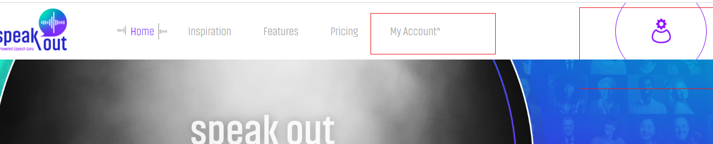

Below are the pages we will be showing after login:

Page 1: Main Page/Recording page https://speakout.visionsdemo.com/pages/home-init

We will display recording time as well as selected recommended topic that a user has chosen from the dropdown.

Note: We might need to change the design of dropdown as you have shared the list and it has approx. 350 topics. It will be difficult for user to choose from dropdown. We need to change the design or approach accordingly.
Please share your thoughts on the same.

The topics are stored in the database, and is randomly picked once the user clicks on recommend topic button. It should be displayed near the screen as chalkboard or anything that looks nice.

Once the user starts recording there will be two icons shown on the screen.
a) Pause: This will pause the video. User can click the icon again to start video.
b) Stop: This will stop the video recording and will open a new screen. See Page 2 for details.
Share Screen - We are sharing the screen and it will be recorded on the video as well.

We found that we discussed the below recording time settings. Do we need to implement the same? Please confirm.
Note: Recording stops by default at 10 min (10 min can be modified in user settings with max of up-to 1.30 hrs.).

Page 2: Recording end/Recording detail page. https://speakout.visionsdemo.com/pages/recording-end

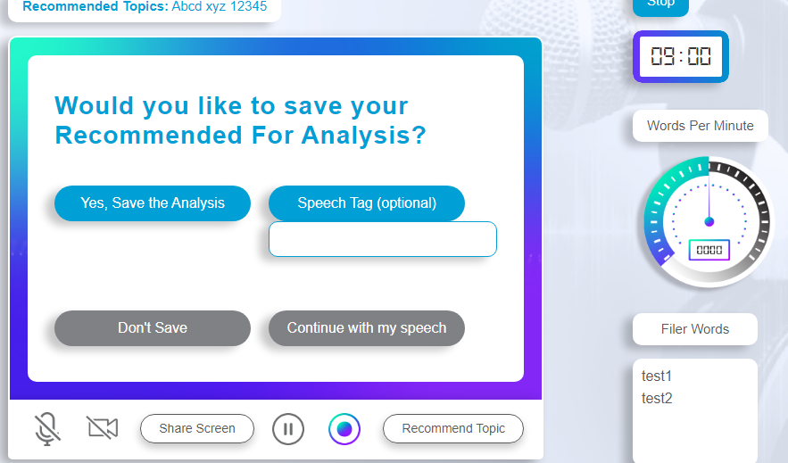

a) Recommended Topics: This will show the topic selected by user on first screen.
Do we need to provide recommended topic dropdown on this screen?
We will either not show the icons like video icon/mute icon/ share screen, or we will disable those since the recording is not done on this section.

b) Yes, Save the Analysis
Clicking on this button will store the analysis on our database.
Video will be sent to S3 bucket.
We will show the message that the recording has been saved successfully.
c) Speech tag
User can choose any tag to differentiate the video for future reference.

- Don’t Save.
Clicking on it will not save the video on our database. However, in case user has free plan then the recorded time will be added on his 10 hours recording time. Please confirm?
10hr max is maximum recording time irrespective of whether the user decides to save the video or not.
Do we need to show any message / alert for confirmation on clicking on it ?
What will be success message to be shown once a user clicks on Don’t save button.

Yes confirm with the user when he/she clicks on don’t save button.

e) Continue with my speech.

This will take user back to recording video page (see page 1 for reference).

f) STOP Button
Please confirm why stop button is on this page, should we remove it from here and add it on page 1. Please confirm?
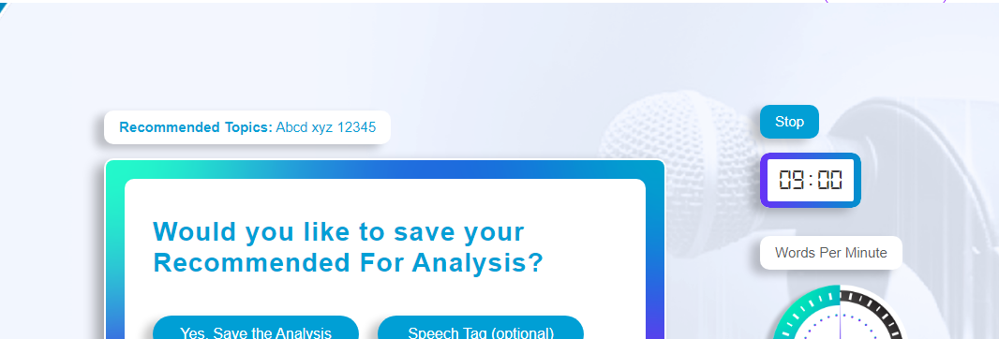

g) Timer –
it will show the total time of the video.

h) Words per minute

No of words the user is speaking per minute. Will be calculated using AWS transcribe (Ref: Streaming transcription).

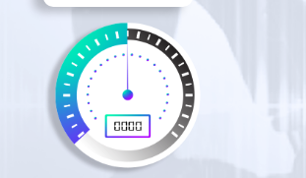

g) Speech Pause
We did not see the speech pause included on this page by designer, but we believe we need to show the graph instead on this page.

We assume we need to show the graph instead of the image, where will show the dots accordingly.

X-axis- Will show the total pauses based on video total time.
Y-axis – will the pause length.

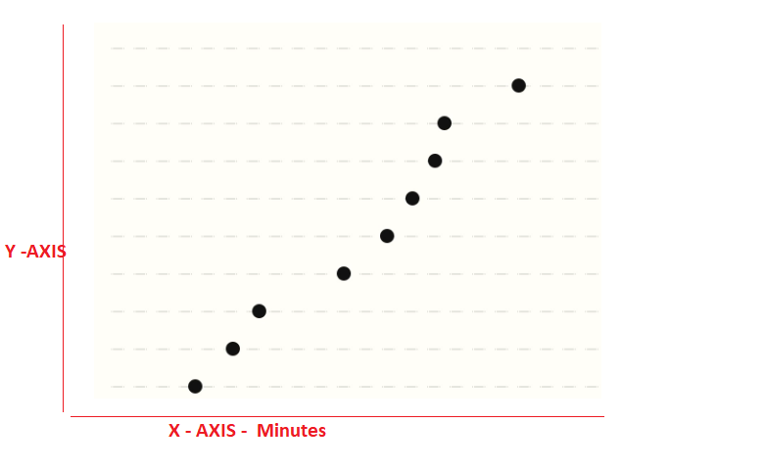

We need designer to provide update mock-up for this page so that we can include graph as well.

This looks correct. Y-axis is pause length in seconds, while X-axis is the time of recording.

d) Filler words
We will show the list of the filler words used on the transcribe.

Clicking on each filler words will open a popup and it will show transcribe and which will have all the words highlighted.
e) Unique Words.

We will show the list of the unique words used on the transcribe.

Clicking on each unique words will open a popup and it will show transcribe and which will have all the words highlighted.

F) Share on social media apps

We will add a social media share icon to share on social media platforms.

G) Download Transcript:

We will add a button to download the transcript. We will be storing the transcript as text file in S3 bucket.

NOTE: We will use the above page as recording detail page which will be shown once a user clicks on recording listing page.

We remember you mentioned on call that there will be scoring on each unique words used. Please confirm how it will be done and where it will be shown?
Please confirm if anything else is required on the page.

I will send you the dictionary of words and their score by this weekend.

Page 3: https://speakout.visionsdemo.com/pages/recording-detail

This page will allow user to search for their already recorded videos.
In case user searches any tag if results on a single result, then it will be redirect on page 2 mentioned above.
However, in case the search yields multiple results we need a page where multiple videos can be shown. So please confirm should be create a page at our end or your designer can send the mock-up for the same. Please confirm.

Page 4: https://speakout.visionsdemo.com/pages/analysis

Download and share option will not be there as it is wrongly shown in mock-up!

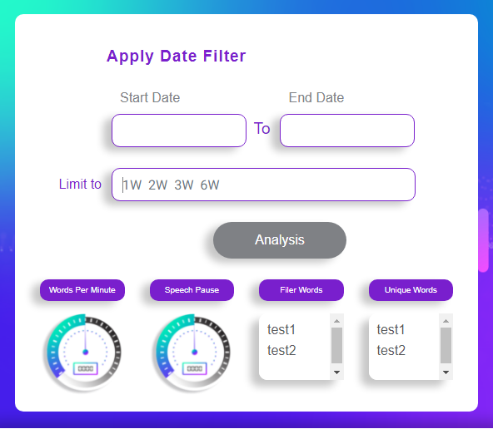

As per our understanding, the filters has two options either to choose from from and to date or use limit text field. Please confirm should we make this a dropdown to choose no of weeks to be used. Please confirm.

Based on filters the below sections will be populated:

- Filler Words – we will show the unique filler words used on the total recordings done so far on that period.
- Unique Words – We will the unique “Unique Words” used on the total recordings done so far on that period.
- Words per minute: it will be average based on the total recording so far.
- Speech Pause - it will be average based on the total recording so far.

